Dear colleagues,

I would like to remind you about International Staff Week at VGTU, which will be held between **23rd and 27th of May 2016** in Vilnius. This week is directed to administrative staff working in international relations offices.

The programme will cover the following topics and activities:

-Incoming and pending challenges of Erasmus+ programme

-Incoming and outgoing student mobility for studies

-Incoming and outgoing student mobility for traineeships

-Staff mobility

-Intercultural Communication

-Workshops and seminars

-Professional trainings by experts

-Case studies

-Campus walk

-Cultural activities (trips, city walk, fun)

The programme will help you to meet your colleagues, get more multicultural and enriching skills, gain valuable work experience and find out interesting facts about magical Vilnius! The programme will be published soon.

Deadline for applying is **4th of April**. Register [online](http://apklausa.lt/f/international-staff-week-23-27-may-2016-registration-form-ru8skra/answers/new.fullpage) (fill in the application and press „Siųsti atsakymą“) and receive the acceptance shortly after deadline, 6th of April.

We will select participants on the basis of interest, institution/country and the principle of the first-come, first-served.

Participation in the International Staff Week is free of charge.

Contact person for International Staff Week: International Relations Office, Ms. Ieva Bagdonaitė, e-mail: [ieva.bagdonaite@vgtu.lt](mailto:ieva.bagdonaite@vgtu.lt)

We hope to see you in May!

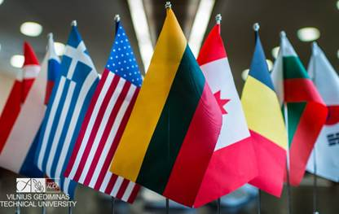

Pagarbiai/Sincerely

Ieva BagdonaitėErasmus Programme Manager

******************************************Vilnius Gediminas Technical UniversityInternational Relations OfficeSauletekio al.11, LT-10223 Vilnius, LithuaniaPhone: +370 5 251 2399, Fax: +370 5 270 0112[www.vgtu.lt](http://www.vgtu.lt/)